Update for key stakeholders
21 October 2022

Vaccination
In the NHS Highland area as a whole, from 10 October to 16 October we delivered –
9,547 COVID-19 vaccinations (12,057 the previous week)
9,144 Flu vaccinations (16,150 the previous week)
18,691 total vaccinations given (28,207 the previous week)
Since the programme started on 05 September we have delivered -

56,396 COVID-19 vaccinations
66,192 Flu vaccinations
122,588 total vaccinations given

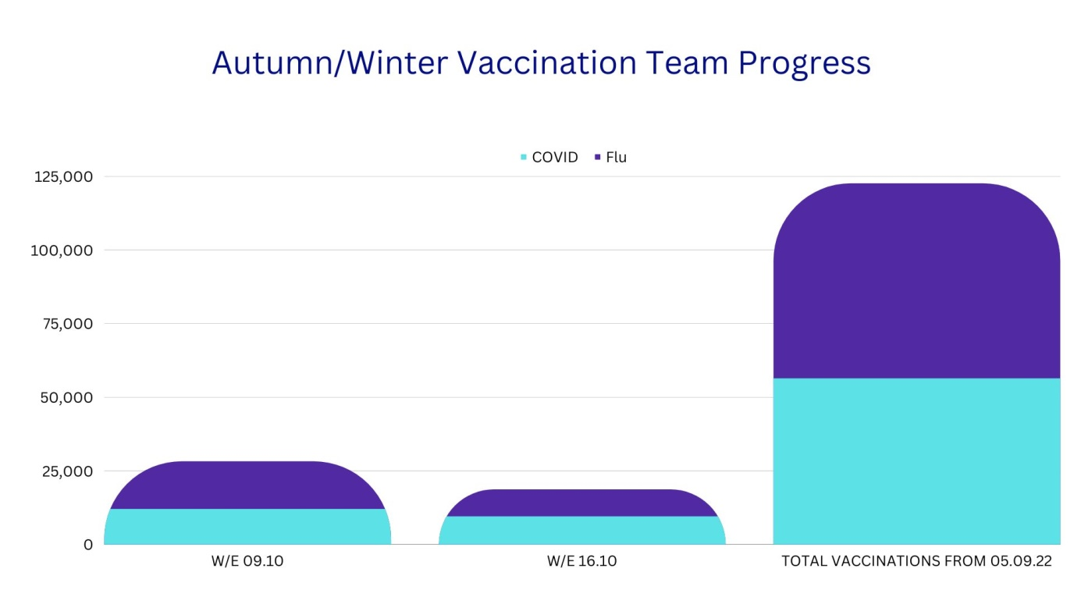

COVID in NHS Highland

After a long period where we have seen the number of COVID-19 cases in NHS Highland declining we have started to see a rise in positive numbers.

Thankfully a smaller percentage of people are becoming seriously ill with COVID-19, this is thanks in large part to the vaccination programme. However, we are seeing an increase in the number of people in hospital who have been admitted for other reasons but then start displaying symptoms and test positive. We have also started to see outbreaks in hospitals resulting in wards being closed to admissions, with patients affected as well as staff.

We are slowly seeing the world moving back to a new normal but COVID-19 has not gone away and is still a very real risk and can still have an impact on people and services.

We are asking everyone to keep using COVID-19 sense and keep doing the things that protect you and your loved ones, particularly if you are visiting healthcare or care home setting.

This includes washing hands regularly, keeping areas ventilated, wearing a face covering when coming into a hospital setting and staying at home if you’re unwell with symptoms or have a fever.

Near Me: Accessing Healthcare from Home

Near Me is a video consultation platform enabling patients across Highland and Argyll and Bute to attend appointments from the comfort of their own home – or anywhere else convenient.

In September 2022, over 1900 individual consultations in NHS Highland took place using Near Me. Each of these consultations meant a patient saved time on travelling, money, and reduced their effect on the environment. Each consultant’s appointment using Near Me in the Highlands saves an average of 100 miles travelled – that’s around 190,000 miles saved last month alone.

There are many appointments covered by Near Me, such as hospital and GP appointments, outpatient appointments, and some treatments such as dietetics and mental health support. From patient feedback, 82.4% of patients said they appreciated not having to travel to their appointments, and 78.1% said it saved them time.

Near Me has so many benefits to patients, but most importantly it gives them options on accessing healthcare in a way that is easy and comfortable for them. Many people are unable to travel far distances to their hospital appointments due to work schedules, caring responsibilities or mobility issues. Near Me saves patients having to take time off work, organise childcare, or arrange transport.

The system is also safe and secure, and very straightforward to use. There is no app to download or registration required. Your details remain private, just like any other appointment. All you need is a device for making video calls, like a smartphone, tablet, or laptop, and an internet connection. If you don’t have these things, Near Me rooms are available in some GP Surgeries and other locations. You can even invite along a friend or family member for support, and they can join the call even if they live far away.

More detail on the various benefits of Near Me will be shared on the ‘Be My Guest’ podcast premiering on Inverness Hospital Radio at 18:00 this Saturday 22 October 2022. Catch it live, or listen to it afterwards on the website’s Listen Again page.

Feedback
If you have comments or queries please contact nhshighland.feedback@nhs.scot

